Relative Imports (Hands On)
- Here, we are going to see how relative imports can be used instead of the %run magic command. We know that the %run magic command is used to run another notebook from the current notebook.
- Before we start, let us explore this notebook.
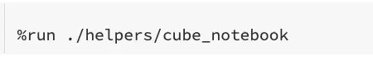
- Here we define Cube class where its constructor accepts one argument which is the edge of the cube. And it has two methods to calculate the cubes volume and surface area.
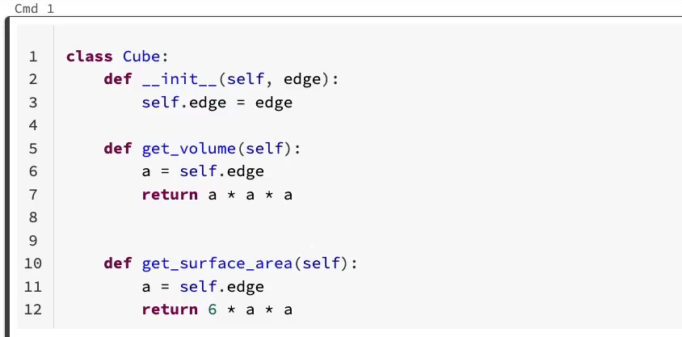

- Let us come back to our notebook. Let us run this cell.
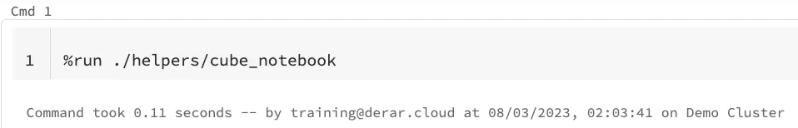
- Now, as you know, all local objects of the reference notebook, such as function variables and classes, will be available here in this notebook. Let us create a cube and calculate its volume.
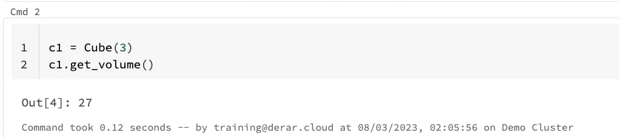

- But since we are using Python, wouldn't it make more sense if we could use something like this for importing our cube class. Let us try to run this cell.

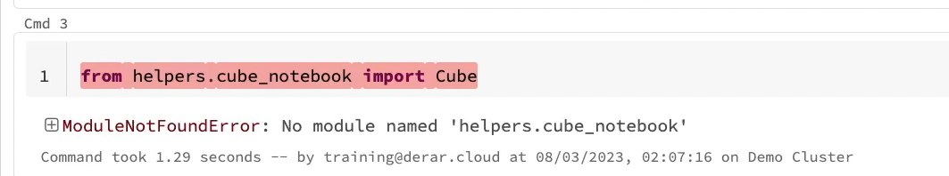

- As you can see, this does not work with Python notebooks. Instead, your code needs to be in a python file with PY extension. Let us create one.
- In Databricks repos, in addition to notebooks, we can create arbitrary files. From here, we can click here Create File.

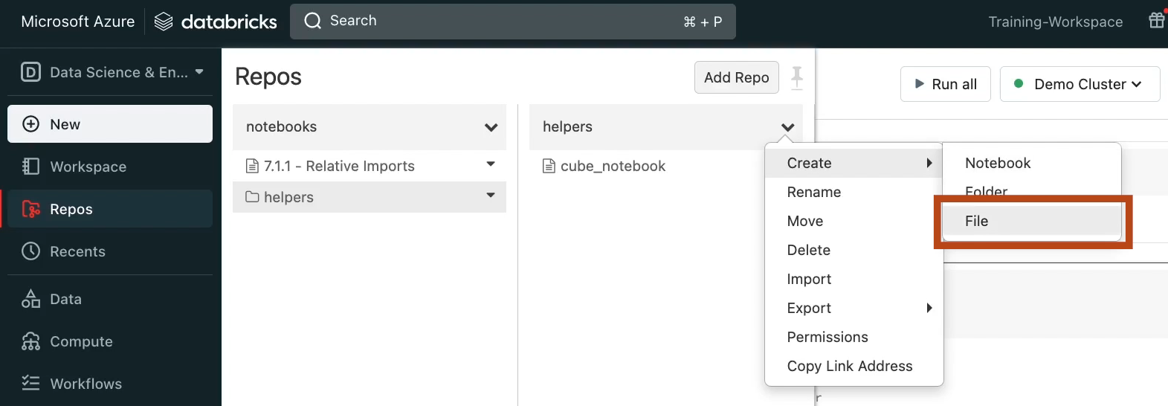

- If you don't see this option, go to your admin console. Under workspace setting. Scroll down to Repose. And make sure to enable the options "Files in Repos" for cluster running Databricks runtime 8.4 and above. Click Save and refresh the page.

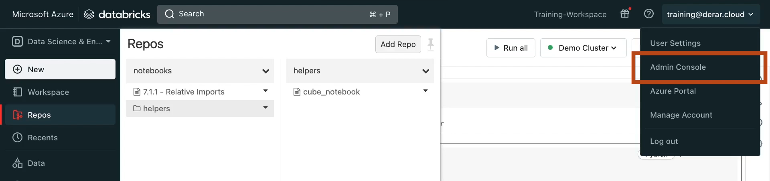

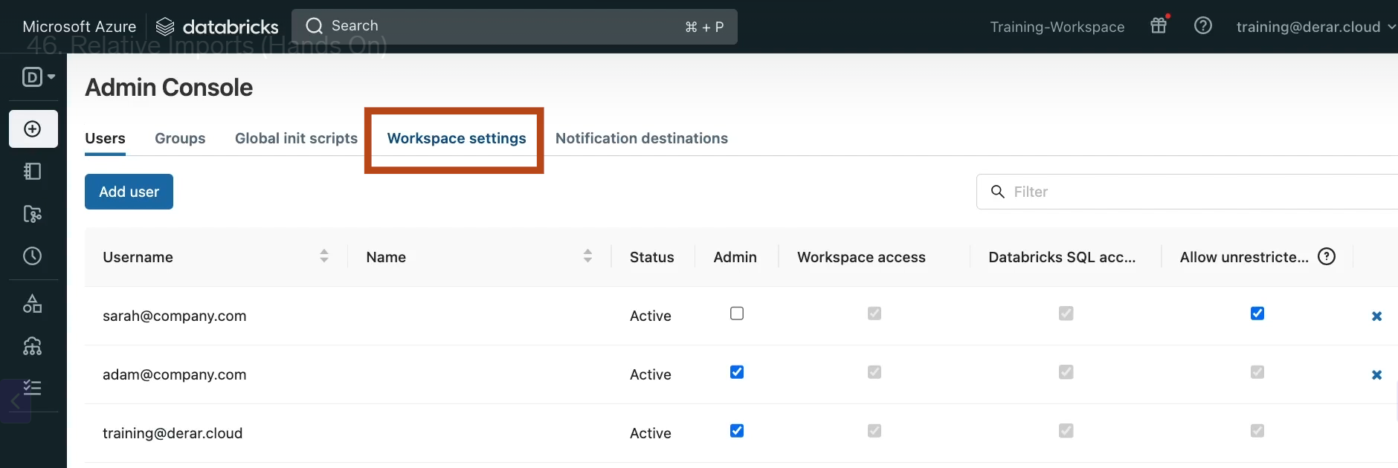

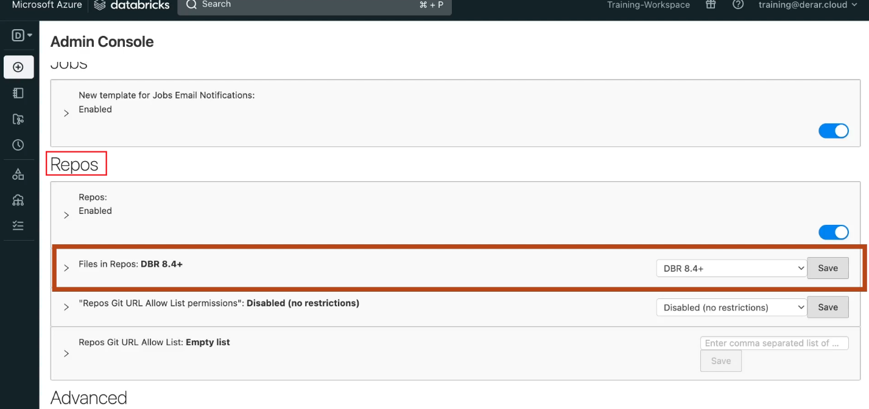

- Now if we come back to our repo. In the “helpers” folder, we can click here. Create -> File. Name it cube.py and hit Create File.

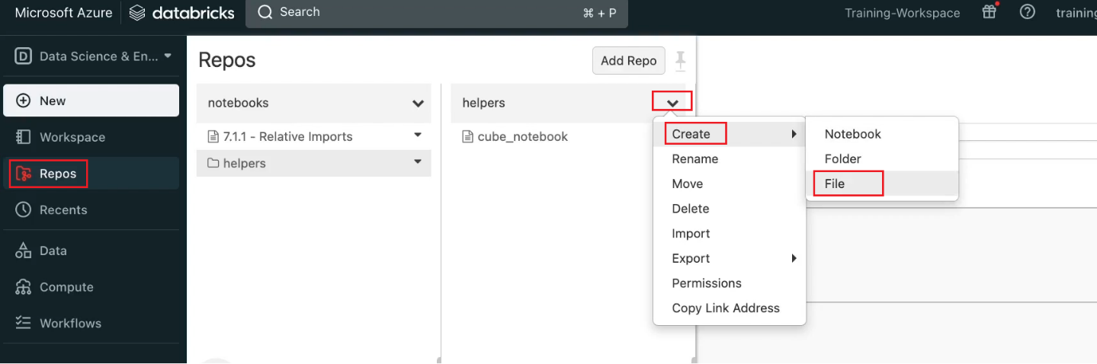

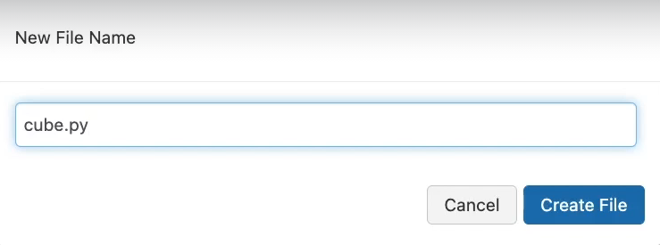
- Let us paste here the code of our Cube class. We will add "_PY" to distinguish this class from the one in the cube notebook.

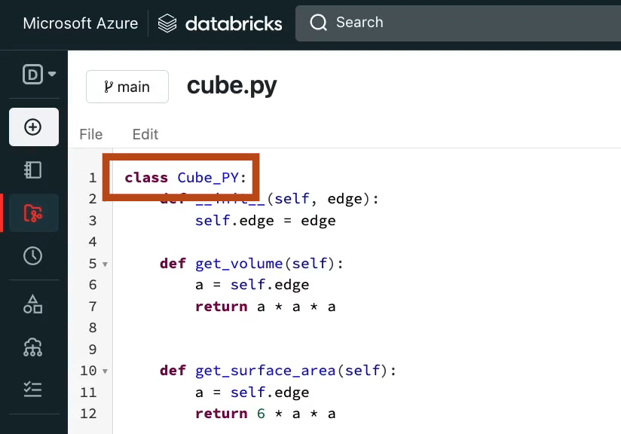

- Now if we come back to our notebook. We can simply type from helpers.cube import Cube_PY. Let us run this. It works.

- While the content of the cube notebook and the cube.py may look identical, if you look at the cube notebook in GitHub. You see a special comment # Databricks notebook source. This is an important comment since it establishes this python file as a notebook. It makes sense now, right.

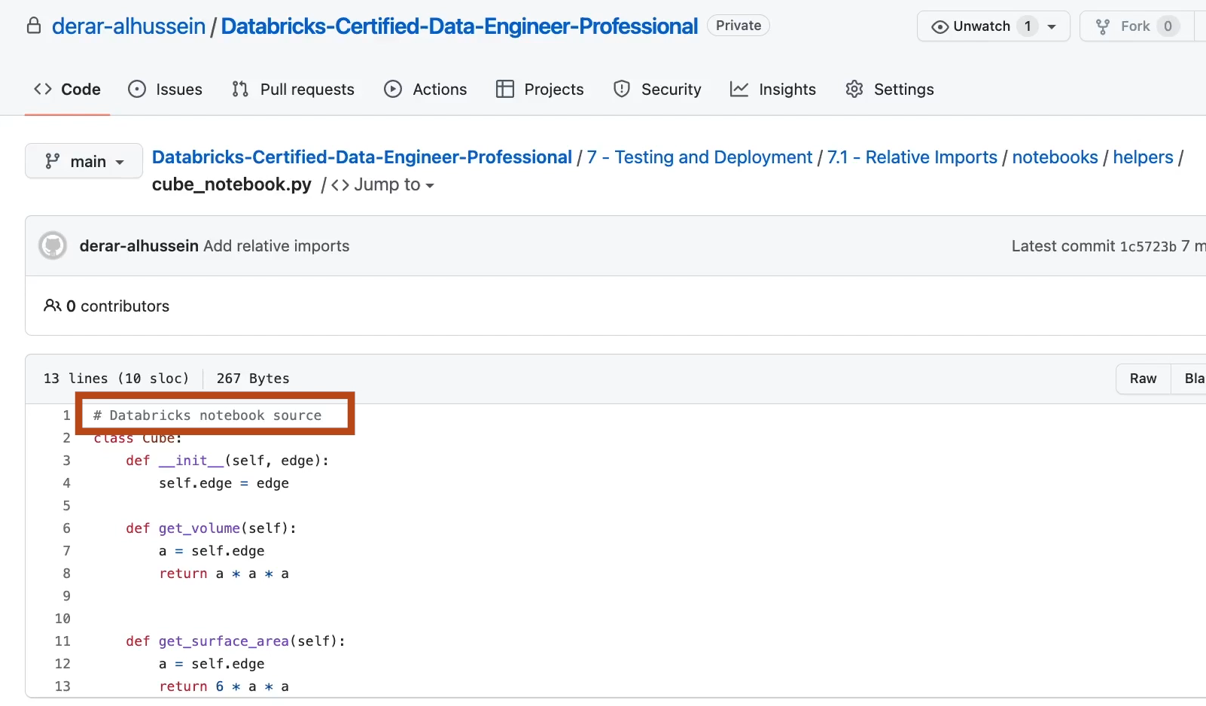

- Let us come back to our notebook. Let us confirm this import by creating a new instance of the class Cube_PY. Let us run this, it works.
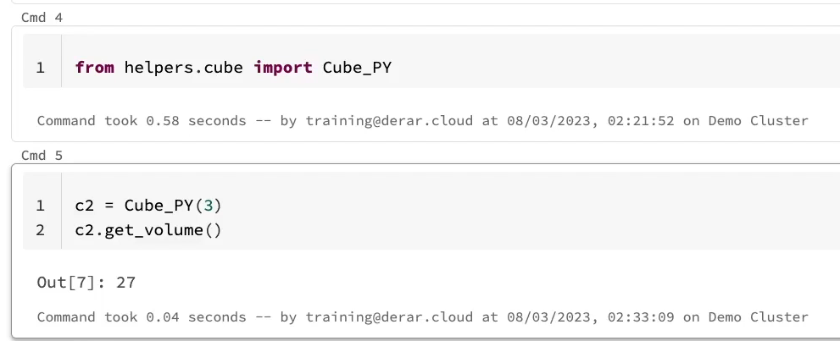

- In fact, this has worked well because the “helpers” subdirectory resides in the current working directory of our notebook. Let us check this. The magic command %sh allows you to run shell code in your notebook. PWD is an acronym for print working directory. Indeed, the notebooks directory containing this notebook is the current working directory.
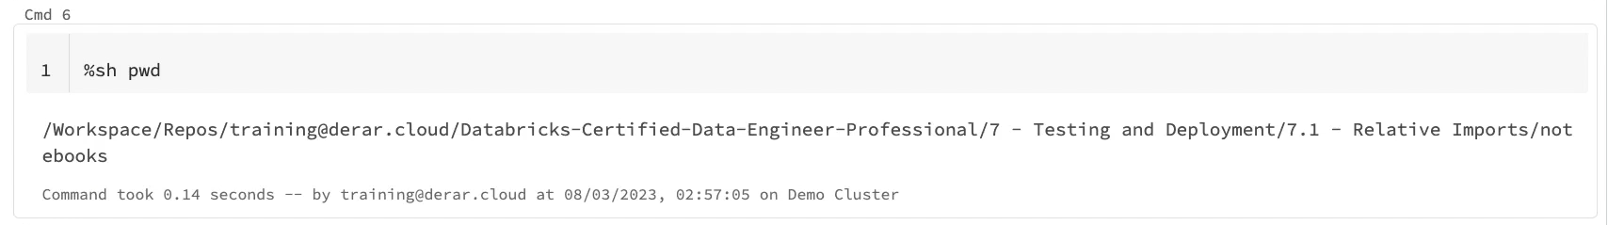

- Other useful shell commands “ls” the command for listing a directory contents.

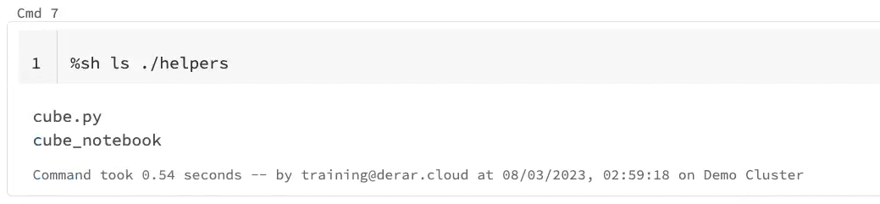

- The current working directory is included in the Python path. If you want to import modules from outside this directory. Like from the modules folder here. You will need first to append it to the path variable.
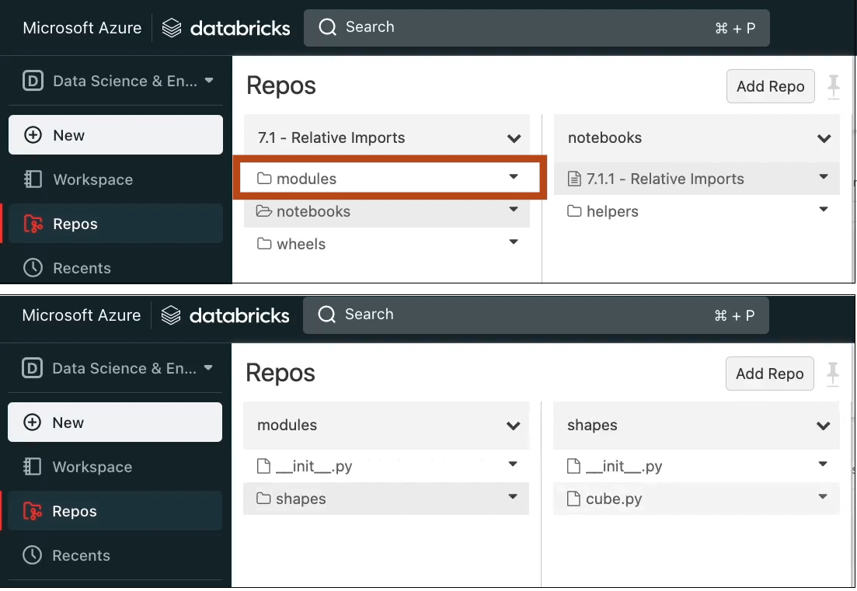

- The “Sys.path” is a list of directories where, Python interpreter searches for modules. To explore the list of directories in the path variable, you need first to import the SYS module. Let us run this. Indeed, here we see our current working directory.

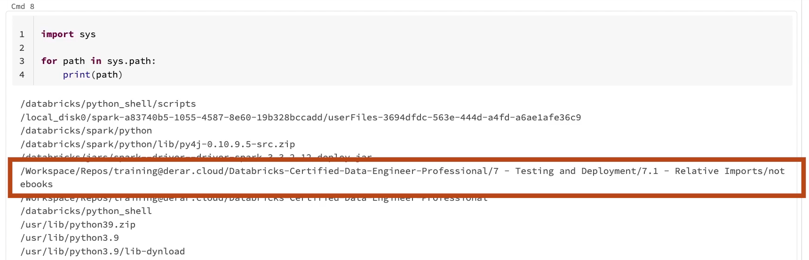

- We can use the method “sys.path” append to add our modules directory to the path variable. Let us run this.
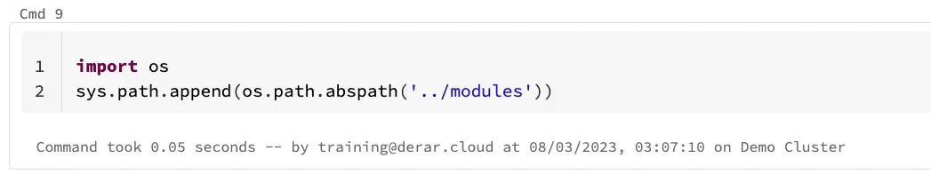

- If we explore again the path variable. We can see now our modules directory.

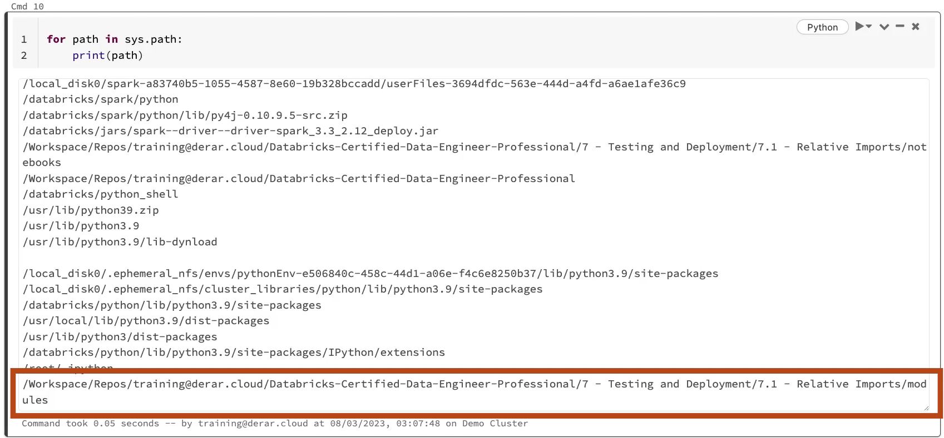

- Now we can import the cubic class from the shapes package found in the modules directory. Let us run & confirm this. It works.

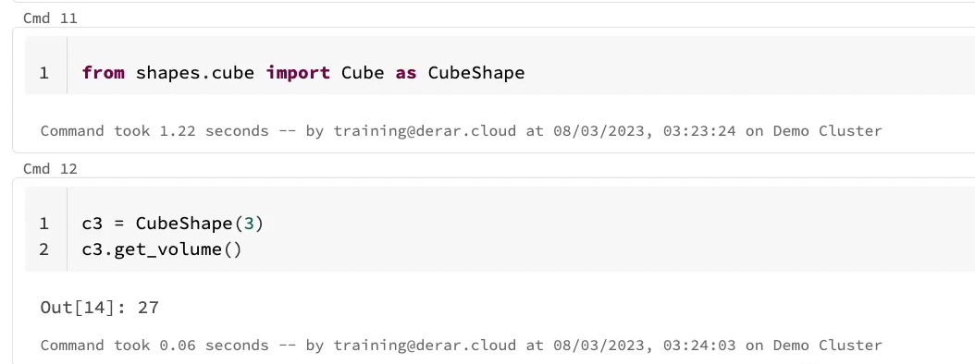

- In Databricks notebooks. You can also install python wheels. Python wheels are prebuilt binary package formats for python modules and libraries. To install a python wheel. We use the pip magic command. PIP install allows to install python wheels scoped to the current notebooks session. Our python will successfully installed in this notebook session. And notice here that the python interpreter has been restarted. This clears all the variables declared in this notebook. This is why you should place all the PIP commands at the beginning of your notebooks.
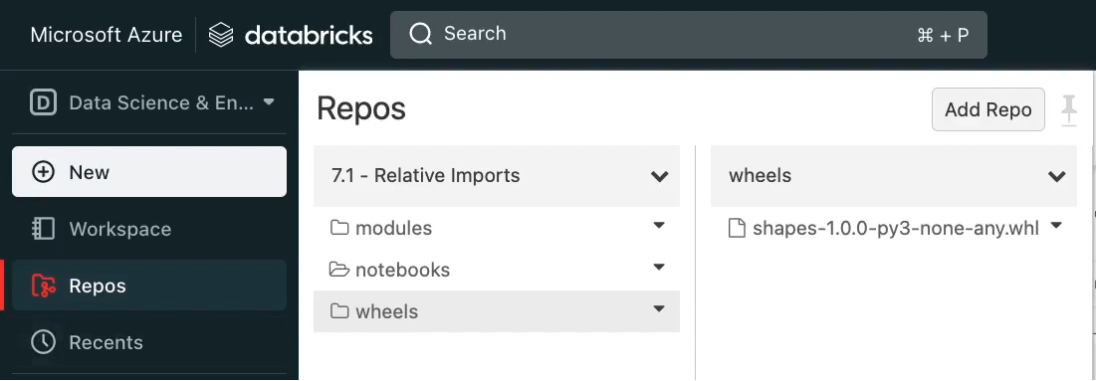

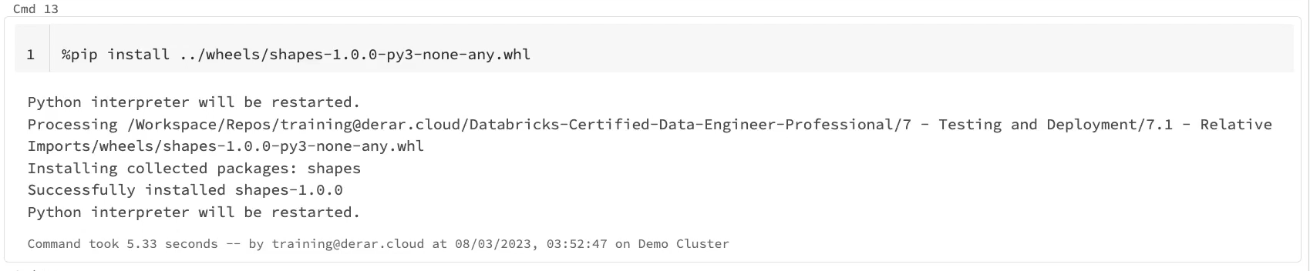

- Now with our wheel installed, we can import our Cube class coming from this wheel. Let us confirm this. It works again.

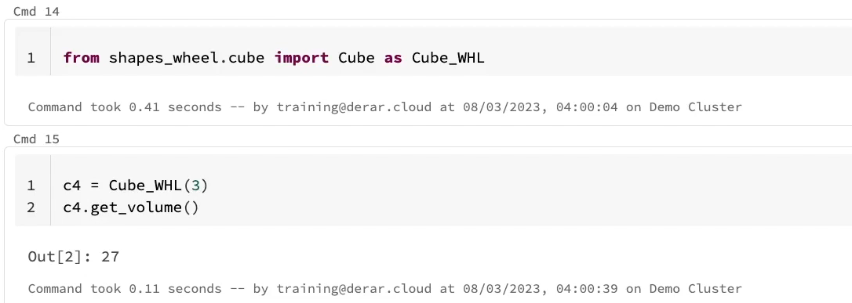

- At the end, you may be wondering why we didn't use the “%sh” magic command for running the PIP install command. In fact, the “%sh” Magic Command executes shell code only on the local driver machine, while with the PIP magic command Python packages will be installed on all the nodes on the currently active cluster.

